PRIMARY SOURCE

South Carolina Ordinance of Nullification
November 24, 1832
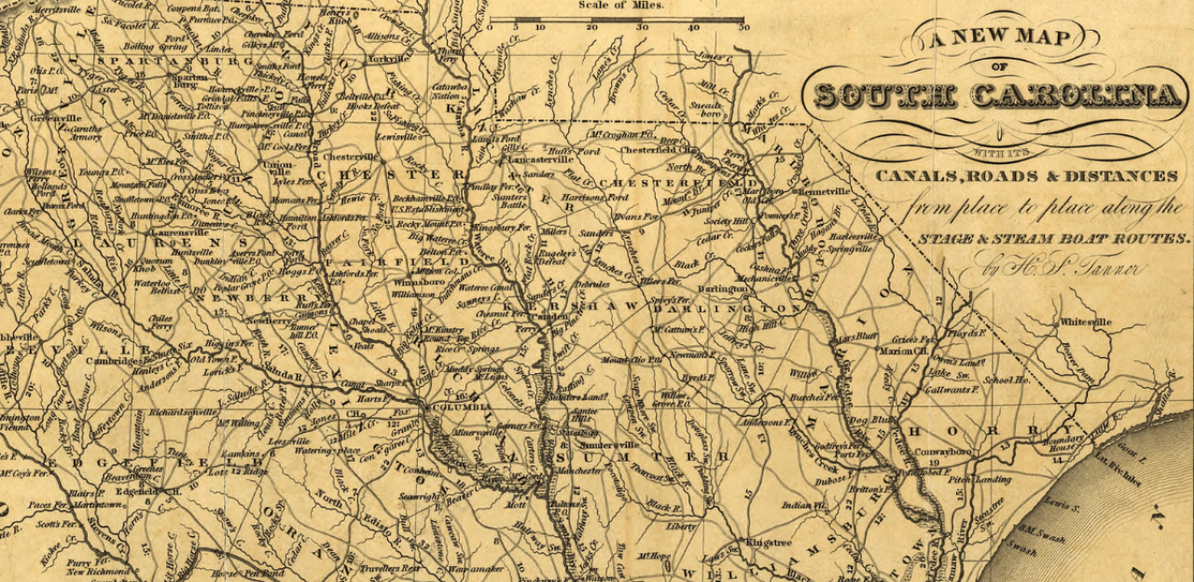Library of Congress
Led by John C. Calhoun, Andrew Jackson’s Vice President, “nullifiers” in the South Carolina convention declared that the tariff acts of 1828 and 1832 were unconstitutional and should be nullified. South Carolina representatives believed that these tariffs favored the North and created an undue economic strain on the South. A compromise between President Jackson and South Carolina was made later that year with the passage of a bill that slowly lowered tariffs over the next decade. However, this crisis emphasized the difference between the North and South and contributed to conflict in the following decades.

An ordinance to nullify certain acts of the Congress of the United States, purporting to be laws laying duties and imposts on the importation of foreign commodities.
Whereas the Congress of the United States by various acts, purporting to be acts laying duties and imposts on foreign imports, but in reality intended for the protection of domestic manufactures and the giving of bounties to classes and individuals engaged in particular employments, at the expense and to the injury and oppression of other classes and individuals, and by wholly exempting from taxation certain foreign commodities, such as are not produced or manufactured in the United States, to afford a pretext for imposing higher and excessive duties on articles similar to those intended to be protected, bath exceeded its just powers under the constitution, which confers on it no authority to afford such protection, and bath violated the true meaning and intent of the constitution, which provides for equality in imposing the burdens of taxation upon the several States and portions of the confederacy: And whereas the said Congress, exceeding its just power to impose taxes and collect revenue for the purpose of effecting and accomplishing the specific objects and purposes which the constitution of the United States authorizes it to effect and accomplish, hath raised and collected unnecessary revenue for objects unauthorized by the constitution.
We, therefore, the people of the State of South Carolina, in convention assembled, do declare and ordain and it is hereby declared and ordained, that the several acts and parts of acts of the Congress of the United States, purporting to be laws for the imposing of duties and imposts on the importation of foreign commodities, and now having actual operation and effect within the United States, and, more especially, an act entitled "An act in alteration of the several acts imposing duties on imports," approved on the nineteenth day of May, one thousand eight hundred and twenty-eight and also an act entitled "An act to alter and amend the several acts imposing duties on imports," approved on the fourteenth day of July, one thousand eight hundred and thirty-two, are unauthorized by the constitution of the United States, and violate the true meaning and intent thereof and are null, void, and no law, nor binding upon this State, its officers or citizens; and all promises, contracts, and obligations, made or entered into, or to be made or entered into, with purpose to secure the duties imposed by said acts, and all judicial proceedings which shall be hereafter had in affirmance thereof, are and shall be held utterly null and void.
And it is further ordained, that it shall not be lawful for any of the constituted authorities, whether of this State or of the United States, to enforce the payment of duties imposed by the said acts within the limits of this State; but it shall be the duty of the legislature to adopt such measures and pass such acts as may be necessary to give full effect to this ordinance, and to prevent the enforcement and arrest the operation of the said acts and parts of acts of the Congress of the United States within the limits of this State, from and after the first day of February next, and the duties of all other constituted authorities, and of all persons residing or being within the limits of this State, and they are hereby required and enjoined to obey and give effect to this ordinance, and such acts and measures of the legislature as may be passed or adopted in obedience thereto.
And it is further ordained, that in no case of law or equity, decided in the courts of this State, wherein shall be drawn in question the authority of this ordinance, or the validity of such act or acts of the legislature as may be passed for the purpose of giving effect thereto, or the validity of the aforesaid acts of Congress, imposing duties, shall any appeal be taken or allowed to the Supreme Court of the United States, nor shall any copy of the record be permitted or allowed for that purpose; and if any such appeal shall be attempted to be taken, the courts of this State shall proceed to execute and enforce their judgments according to the laws and usages of the State, without reference to such attempted appeal, and the person or persons attempting to take such appeal may be dealt with as for a contempt of the court.
And it is further ordained, that all persons now holding any office of honor, profit, or trust, civil or military, under this State (members of the legislature excepted), shall, within such time, and in such manner as the legislature shall prescribe, take an oath well and truly to obey, execute, and enforce this ordinance, and such act or acts of the legislature as may be passed in pursuance thereof, according to the true intent and meaning of the same, and on the neglect or omission of any such person or persons so to do, his or their office or offices shall be forthwith vacated, and shall be filled up as if such person or persons were dead or had resigned; and no person hereafter elected to any office of honor, profit, or trust, civil or military (members of the legislature excepted), shall, until the legislature shall otherwise provide and direct, enter on the execution of his office, or be he any respect competent to discharge the duties thereof until he shall, in like manner, have taken a similar oath; and no juror shall be impaneled in any of the courts of this State, in any cause in which shall be in question this ordinance, or any act of the legislature passed in pursuance thereof, unless he shall first, in addition to the usual oath, have taken an oath that he will well and truly obey, execute, and enforce this ordinance, and such act or acts of the legislature as may be passed to carry the same into operation and effect, according to the true intent and meaning thereof.
And we, the people of South Carolina, to the end that it may be fully understood by the government of the United States, and the people of the co-States, that we are determined to maintain this our ordinance and declaration, at every hazard, do further declare that we will not submit to the application of force on the part of the federal government, to reduce this State to obedience, but that we will consider the passage, by Congress, of any act authorizing the employment of a military or naval force against the State of South Carolina, her constitutional authorities or citizens; or any act abolishing or closing the ports of this State, or any of them, or otherwise obstructing the free ingress and egress of vessels to and from the said ports, or any other act on the part of the federal government, to coerce the State, shut up her ports, destroy or harass her commerce or to enforce the acts hereby declared to be null and void, otherwise than through the civil tribunals of the country, as inconsistent with the longer continuance of South Carolina in the Union; and that the people of this State will henceforth hold themselves absolved from all further obligation to maintain or preserve their political connection with the people of the other States; and will forthwith proceed to organize a separate government, and do all other acts and things which sovereign and independent States may of right do.
Done in convention at Columbia, the twenty-fourth day of November, in the year of our Lord one thousand eight hundred and thirty-two, and in the fifty-seventh year of the Declaration of the Independence of the United States of America.

